**BGP for IPv4**

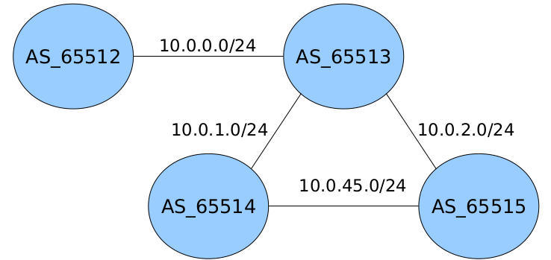

**Enunciado**

* Crea la arquitectura anterior con BGP e IPv4.
* Prefijos anunciados:
  + AS_65512 → 10.12.0.0/16, 172.16.12.0/24, 192.168.0.0/23
  + AS_65513 → 10.13.0.0/16
  + AS_65514 → 10.14.0.0/16, 172.16.14.0/24
  + AS_65515 → 10.15.0.0/16, 172.16.15.0/24, 192.168.128.0/23

**Solución**

// ******************************** TOPOLOGÍA DE LA RED ****************************************

mkdir uml{1..4}

kwrite net.conf

// net.conf

defsw sw12 uml1.0 uml2.2

defsw sw23 uml2.1 uml3.0

defsw sw24 uml2.0 uml4.1

defsw sw34 uml3.1 uml4.0

sudo ifovsdel

sudo ifovsparse net.conf

lanza {1..4}

// ******************************** CONFIGURACIÓN ***********************************************

Levantar los demonios y reiniciar quagga en todos los encaminadores:

sed -i -e 's/bgpd=no/bgpd=yes/' /etc/quagga/daemons  
service quagga restart

Encaminadores:

1º) UML1

vtysh

configure terminal

ip forwarding

interface eth0

ip address 10.0.0.2/24

do write

exit

router bgp 65512

bgp router-id 0.0.0.2

neighbor 10.0.0.3 remote-as 65513

network 10.12.0.0/16

network 172.16.12.0/24

network 192.168.0.0/23

do write

2º) UML2

vtysh

configure terminal

ip forwarding

interface eth0

ip address 10.0.2.3/24

interface eth1

ip address 10.0.1.3/24

interface eth2

ip address 10.0.0.3/24

do write

exit

router bgp 65513

neighbor 10.0.0.2 remote-as 65512

neighbor 10.0.1.4 remote-as 65514

neighbor 10.0.2.5 remote-as 65515

network 10.13.0.0/16

do write

3º) UML3

vtysh

configure terminal

ip forwarding

interface eth0

ip address 10.0.1.4/24

interface eth1

ip address 10.0.45.4/24

do write

exit

router bgp 65514

neighbor 10.0.1.3 remote-as 65513

neighbor 10.0.45.5 remote-as 65515

network 10.14.0.0/16

network 172.16.14.0/24

do write

4º) UML4

vtysh

configure terminal

ip forwarding

interface eth0

ip address 10.0.45.5/24

interface eth1

ip address 10.0.2.5/24

do write

exit

router bgp 65515

neighbor 10.0.2.3 remote-as 65513

neighbor 10.0.45.4 remote-as 65514

network 10.15.0.0/16

network 172.16.15.0/24

network 192.168.128.0/23

do write

// ******************************** COMPROBACIÓN ************************************************

show ip bgp

show ip route bgp